Fraction Darts Games in Progress – What Should You Do?

Name______________________________

In each of the following problems, a game of Fraction Darts is being played. Look at the picture of the game and answer the questions.

- One dart has been thrown:

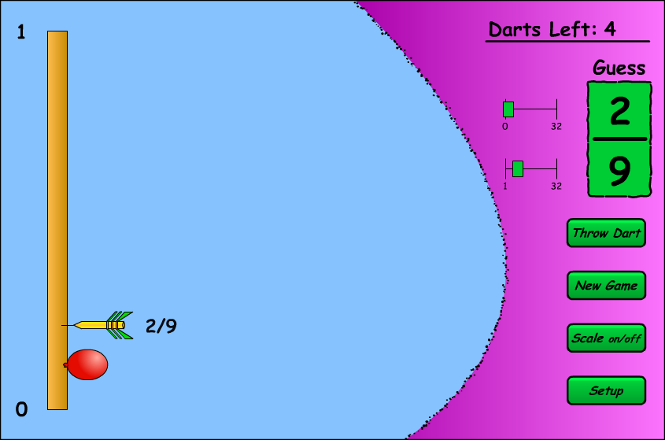

For the next throw, what would the best guess be? Why? Explain your answer.

- Two darts have been thrown:

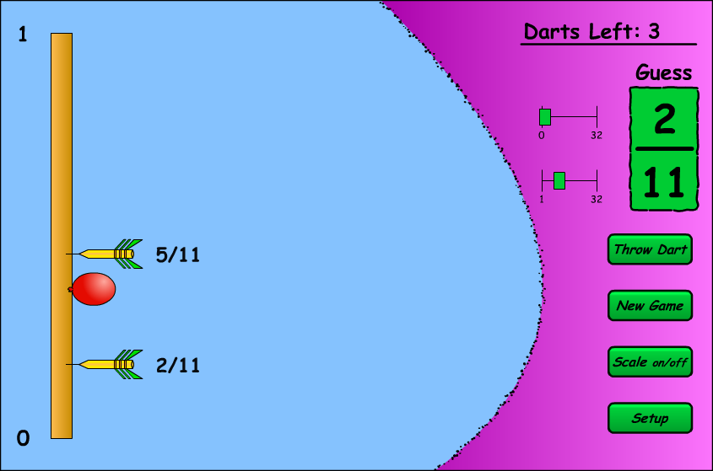

For the next throw, what would the best guess be? Why? Explain your answer.

- Two darts have been thrown:

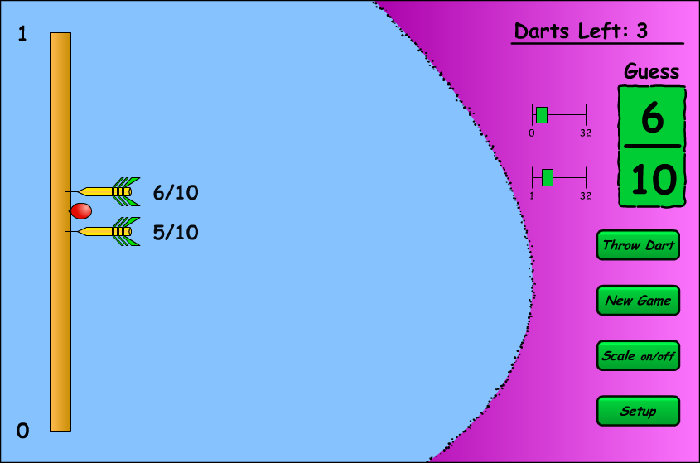

For the next throw, what would the best guess be? Why? Explain your answer.

- Two darts have been thrown:

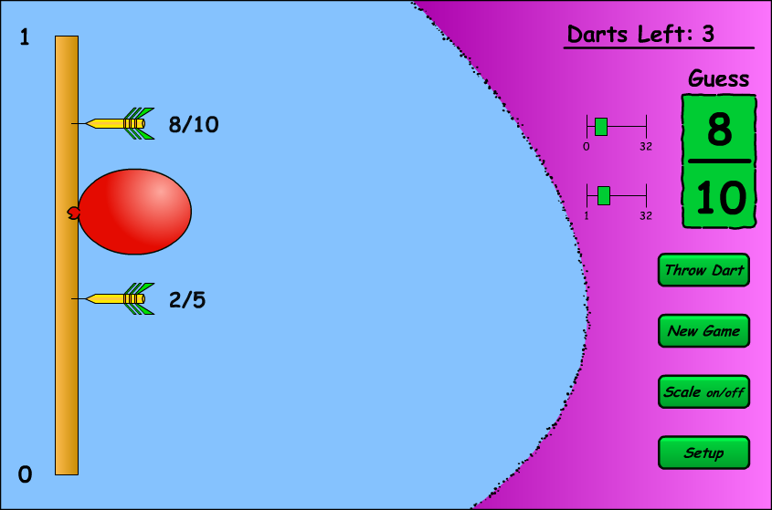

For the next throw, what would the best guess be? Why? Explain your answer.

- One dart has been thrown:

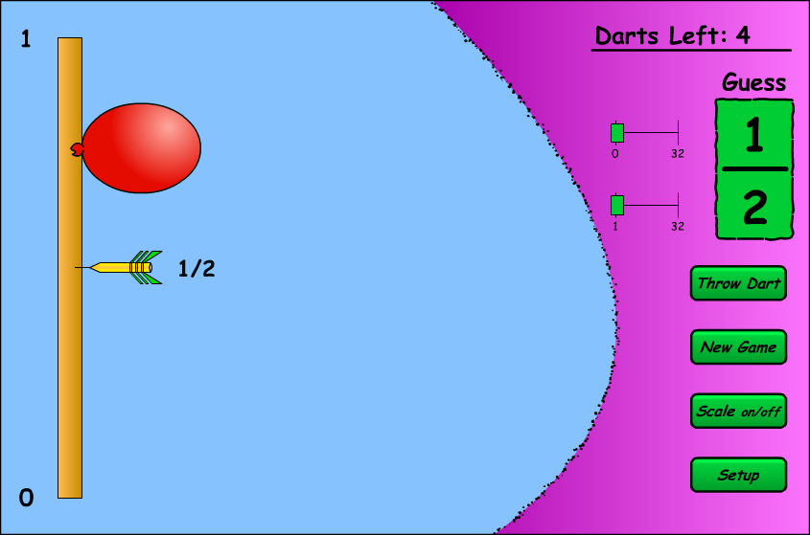

For the next throw, what would the best guess be? Why? Explain your answer.

- Two darts have been thrown:

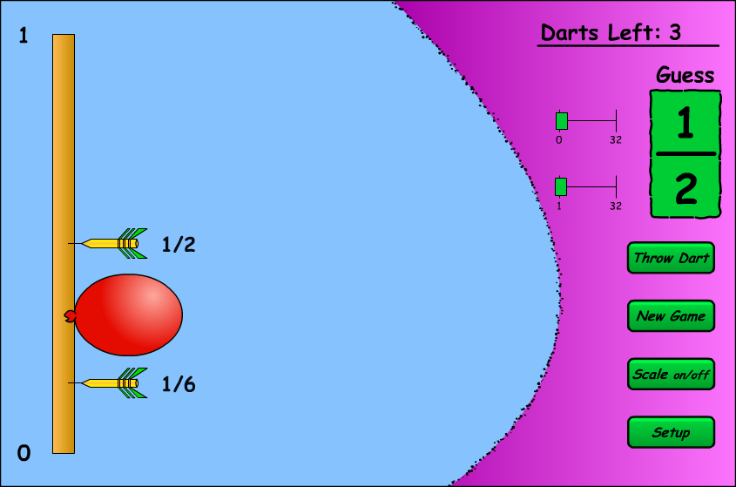

For the next throw, what would the best guess be? Why? Explain your answer.

- Four darts have been thrown:

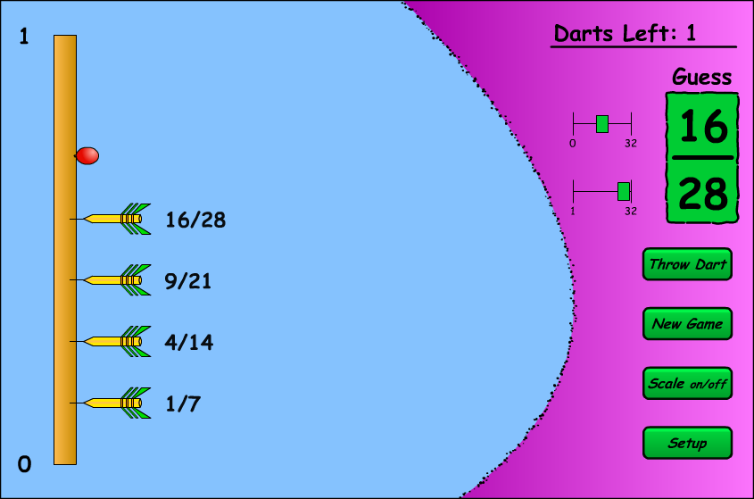

For the next throw, what would the best guess be? Why? Explain your answer.

